Considering what you have learnt about Multiple Intelligences, learning styles, UDL, and tips for literacy-accessibility, how would you make this piece of communication more literacy-friendly?

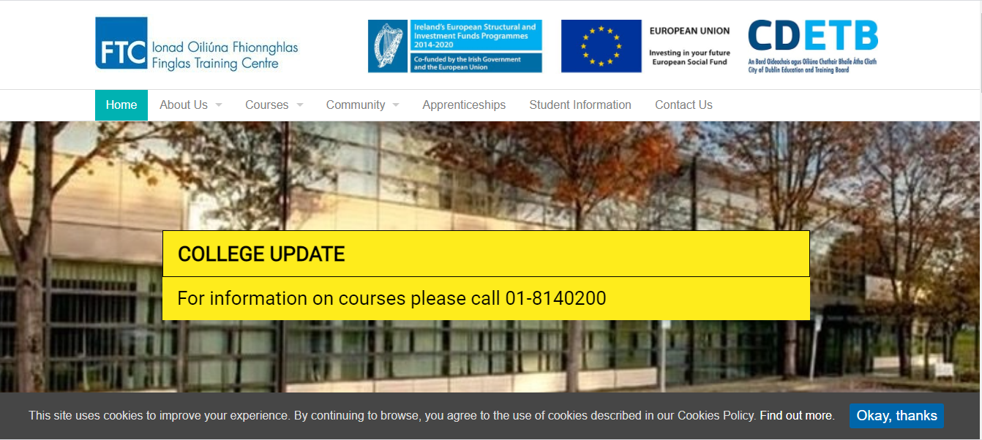
https://finglastrainingcentre.ie/

