Considering what you have learnt about Multiple Intelligences, learning styles, UDL, and tips for literacy-accessibility, how would you make this piece of communication more literacy-friendly?

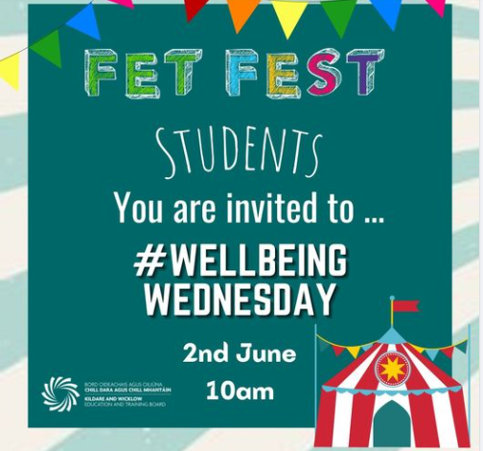

https://www.facebook.com/CityDublinETB/

