An Introductory Guide to Blending a Course: Strategies for Blended Delivery

Development of this Resource

This FESS handbook is designed to support those delivering FET programmes who have been tasked with converting a fully face-to-face course to one with an online/remote element (i.e. the blended element) for learners. Blended learning is a mode of delivery allowing learners to complete their course of study by a combination of in centre face-to-face, work based and online learning.

This handbook focuses primarily on the online element of the blended learning activity. We refer to those with online teaching and assessment roles as educators. This term refers to various roles that exist in the FET sector, including assessor, facilitator, instructor, lecturer, teacher, trainer, tutor, etc. The term course will be used to mean the programme or course that is being delivered based on the validated programme.

Programmes validated by QQI have a set of learning outcomes associated with them at programme and/or module level. It is vital to ensure that the delivery of the programme, whatever delivery mode is used, provides learners with a range of appropriate learning opportunities. Opportunities will also have to be provided to learners to allow them to demonstrate achievement of the relevant learning outcomes.

Working Group Members:

Finola Butler, FESS

Liz Hogan, Blended Learning Expert

Mary Sheehy, FESS

FESS would like to acknowledge the valuable contribution provided by Dr. Michael Hallissy, H2 Learning.

Published by FESS: 2020

Table of Contents Page

List of figures 4

List of tables 4

Glossary 5
Section One: Introduction 7
Blended learning: Balance between online and offline 7
The ADDIE Model 9
Section Two: Analysis 12
Course overview structure 12
Assessment of learning 15
Course timetable 15
IT resource requirements 17
Staff resources including upskilling/training requirements 18
Protocols and guidelines including those for the online environment 19
Learner profile 20
Information for learners about the course 20
Section Three: Design 22
Online course overview 22
Designing content 22
Resources and tools for delivering content 23
The layout and design of the eLearning platform 27
The layout and design of the content for upload to the eLearning
platform 28
Section Four: Development 30
Creating an engaging online environment 30
Contact learners prior to the course commencement date 30
Create an introductory activity/ice breaker to begin engagement on
the course 31
Creating online content 31
Creating content using digital tools to support independent learning 33
Creating content using digital tools to facilitate collaborative learning 36
Creating content for the virtual classroom 38
Section Five: Implementation 41
Induction 41
Course Delivery 42
Maintaining an engaging environment 42
Providing feedback on assessment tasks to learners 43
Some issues that can be encountered during online delivery 43
Section Six: Evaluation 45
Ten sample questions for learner feedback on the online experience 46
Using the eLearning platform functionality to support the evaluation
process 47
Reference List 48
Bibliography 49

List of Figures Page
Figure 1: The ADDIE model 9
Figure 2: Sample planner 14
Figure 3: Sample timetable 17
Figure 4: Sample course homepage from Moodle 27
Figure 5: Sample module outline on Moodle 28
Figure 6: Sample topic outline on Moodle 29
Figure 7: Sample plan for virtual classroom (1 hour) 40

List of Tables
Table 1: Possible approaches/digital tools 24
Table 2: Sample approach/digital tools for the delivery of a topic 26
Table 3: Examples of how learner feedback could be gathered 46

Glossary

In this document the following terms are used:

ADDIE: ADDIE is an acronym for the five steps of a development process which can be followed to transform a face-to-face course to a blended learning mode. ADDIE stands for: Analysis; Design; Development; Implementation; Evaluation

Asynchronous activity: Learners engage with material online at different times and different locations that suit their personal needs. Example of learning material or activities include pre-recorded videos, self-guided lesson or quizzes.

Centre: Physical location for the delivery of face-to-face classes from the educator to learners.

Collaborative Learning: Two or more participants learn something together to expand their knowledge of a certain topic by discussing concepts and creating solutions

Course: A programme/series of lessons and outcomes that is being delivered based on the provider’s validated programme.

Educator: A person who provides instruction or education. This includes teacher, tutor, trainer, instructor, facilitator and lecturer

eLearning: Short for electronic learning. This is where the learner has access to material from their programme though the internet with the support of digital tools. This occurs outside of the traditional face-to-face centre.

eLearning Platform: This refers the any learning management system which facilitates the delivery of the course content. Can be used to deliver both online asynchronous and synchronous learning material/activities.

FESS: The Further Education Support Service (FESS) is a SOLAS-funded support service that provides consultancy and support to publically-funded FET providers.

FET: Further Education and Training

Independent Learning: Learners individually take responsibility for their own learning to complete formative and summative content or assessment. Also, known as self-directed learning. The provision of feedback be the educator is vital to support learners with their independent learning

NFQ: The NFQ (National Framework of Qualifications) is a system of levels for relating different qualifications (i.e. awards) to one another

Offline content: Content that is provided to facilitate learning to be completed face-to-face in a centre setting and/or learning during work placement. The learning is not completed online using IT equipment.

Online Content: Content/material that is available to learners on the eLearning platform and the internet. This can include text, images, animations, music and videos.

QA: Quality assurance. FET providers have quality assurance systems in place to support the delivery of programmes leading to QQI awards

QQI: QQI (Quality and Qualifications Ireland) is an independent state agency responsible for promoting quality and accountability in education and training services in Ireland.

Synchronous activity: Learners engage in learning at the same time but not the same location with activities such as a webinar or chat. Educators and learners engage in real time.

TEL: Technology Enhanced Learning

Section 1: Introduction

This handbook is designed to support those delivering blended courses with simple strategies to help make the process of planning, designing, developing, implementing, and assessing online content smooth and effective. Whether you are starting as a beginner or have some experience in creating and implementing content online, communication with remote learners over a sustained period may be a new challenge.

QQI refers to Garrison and Kanuka’s definition of blended learning as “the integration of classroom face-to-face learning experiences with online learning experiences” (2018, p.3). Driscoll and Carliner (2005) identified four typologies of pedagogy which could be blended learning, namely:
- a mix of web-based technologies
- a mix of various pedagogical approaches (for example, constructivism, behaviourism, cognitivism)
- a combination of any form of instructional technology with face-to-face instructor-led conditions
- a combination of instructional technology with actual job tasks to form an effective mix of learning and working.

The focus of the current learning environment is to shift from traditional classroom to delivering some elements of a course online. In a blended learning environment educators can create and upload content online at a pace appropriate to both educator and learner capabilities while also meeting centre requirements. This makes change easier to accept for all involved. The design of a blended course and its implementation will vary for each individual course.

Blended learning: Balance between online and offline

As blended learning combines online and offline content, it is important that both the online and offline content complement and support each other to reinforce the learning. There needs to be an appropriate balance between the online and the offline or face-to-face delivery of the course. According to Allen, Seaman and Garrett (2007) the breakdown between online and offline or face-to-face delivery may vary from 30-79% online and 21-79% offline for it to be considered a blended learning course. However, the precise ratio(s) on the breakdown between online and classroom and/or work placement based delivery will be managed by each provider’s QA system as agreed with QQI. Please note during the current COVID 19 pandemic and due to current social distancing guidelines, the ratio breakdown is continually changing and must be monitored and adhere to QQI guidelines as time progresses.

An Erasmus research project (Baloh, T. et al., 2019) identified five tips for quality blended learning:
  - Start with the learning outcomes
  - Teaching leads the technology
  - Group work can be effective
  - Source online resources
  - Assessment ideally should be blended

Since the establishment of public education, the vast majority of courses in the FET sector have been delivered in a traditional face-to-face environment. Face-to-face learning is a mode of delivery where course content and learning material is taught to a learner or group of learners in person. Due to emerging changes in the education and training environment, providers may be exploring appropriate blended learning opportunities for specific courses to meet the needs of a range of learner cohorts. When moving from traditional face-to-face delivery to a blended mode, the ADDIE model may be an effective learning design framework to consider. The approach used in this handbook is based on the ADDIE model.

The potential flexibility provided by blended courses is a growing opportunity for educators. The online learning environment allows learners the potential for greater flexibility to access and engage in learning activities in their own time and at a location that suits them. However, it can also be a lonely experience for the learner. Therefore, the more engaging you can make the learning experience the more likely the learners will remain engaged with the course. It is imperative that online educators reinforce learning and foster interaction throughout the duration of any course.

The ADDIE Model

ADDIE is an acronym for the five steps of a development process which can be followed to transform a face-to-face course to a blended learning mode. ADDIE stands for:
- Analysis
- Design
- Development
- Implementation
- Evaluation.

(Adapted from Erasmus research project (Baloh, T. et al., 2019))

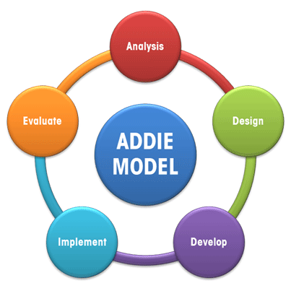

Figure 1: The ADDIE model

This model relies on each stage being completed in order, with a focus on reflection throughout the process to facilitate continuous improvement.

Analysis - This stage is essential and must be completed before contemplating content design and development. It is important to
- analyse current circumstances in terms of programme(s), stakeholders, resources and training needs
- Identify existing learner knowledge, skill and competence as well as what they should know on completion of the course
- analyse learning outcomes that need to be achieved
- consider possible constraints and challenges.

All the above will influence any decisions made throughout the process.

Design - This includes identifying
- course structure
- duration of online/offline elements
- duration the learners are in the centre
- delivery methodologies
- learning outcomes that may be best delivered online and/or in centre and/or in the work place, if appropriate
- different types of assessment
- learner feedback methods
Within online learning there are two options available to course designers. Synchronous/live delivery to learners and asynchronous delivery where learners do work in their own time. The design stage can involve creating storyboards, identifying the flow of the course, identifying the materials/facilities/equipment needed, how the course will be staged, what technologies, packages, apps will be needed to deliver the course, etc.

Development – In this stage, the content is ready to be developed. Content for each learning outcome of the course is created, guided by the storyboards/flow of the course from the design stage. Activities will need to be developed that engage learners online with digital tools, for example, creating quizzes, interactive presentations and videos.

Implementation – This stage involves the delivery of the content to the learners, whether that is online or offline. It also focuses on creating an engaging online environment that facilitates strong communication between the online educator and the learner. This stage will also have co-construction of knowledge with educators and learners learning from and with one another.

Evaluation –in this stage feedback is gathered from learners and other stakeholders and opportunities for self-reflection are considered to establish what worked well and perhaps what did not work so well. Based on the evaluation, the course can be revised for subsequent iterations. There may be ongoing evaluation at each stage of the process followed by a final evaluation at the end of the course.

While the analysis and evaluation sections of this handbook focus on the overall blended programme, including online and face-to-face (centre-based and workplace) elements of the course, the design, development and implementation sections of this handbook will focus primarily on supporting the online educator for the eLearning platform and the virtual classroom.

Section Two: Analysis
The analysis takes place at the beginning of the process to identify what exactly is needed for a course to be delivered via a blended learning mode. The balance between online, face-to-face and work-based elements will depend on the individual course learning outcomes and the needs of the centre and learners. For example, online learning may only be a minor element of a course or, in contrast, learners may work independently online and intermittently meet with online educators to review their learning progress or receive support.

To explore the balance of online and offline delivery a full analysis should be carried out and the following factors should be considered.

Course overview and structure

To plan a course for blended delivery, it is important for programme managers to create a clear and consistent structure for the entire course. This may involve working with colleagues where several modules are being delivered as part of the course. Analysing the entire course may help to identify areas of overlap in content across and within modules and similarity in the type of content that is delivered over the entirety of the course. This will help support the delivery and flow of the course for both the online educator and the learner. Planning the flow of the course should bring clarity to how and where different elements of the course are being delivered in a logical and sequential manner.

It is necessary to consider the following two steps:

Step 1: Structuring course content
  - all topics of the course (based on the validated programme)
  - the learning outcomes that must be achieved
  - the assessments required

Group similar topics, within and across modules, into sections and arrange the topics in a logical sequence for delivery

Step 2: Within each section identify
  - the most suited mode(s) of delivery for each learning outcome
  - the teaching and learning methodologies that are most suited to facilitate learner engagement.
  - the summative assessment tasks

Tip: Online educators should have the confidence to give up some control to facilitate learners in taking more responsibility for their own learning thereby giving learners control over some aspects of time, place and pace during their studies.

Sample outline of how an educator matches sections, topics, learning outcomes (and related modules) with the mode of delivery, associated teaching and learning methodologies and summative assessment tasks.
Section (Grouped Topics) | Learning Outcome(s)  (LOs) | Module Title | Mode of delivery | Teaching and Learning Methodologies | Summative Assessment Task/s
1 | LO 1 & 3 | Module 1 | Centre-based | Workshop (face-to-face)
2 | LO 5  LO 6 & 7 | Module 1  Module 4 | Work Placement | Work experience
3 | LO 5 & 8 | Module 4 | Online (Asynchronous) | Independent learning
4 | LO 3 & 4 | Module 2 | Online (Asynchronous and Synchronous) | Collaborative learning using digital tools (e.g. Forum, breakout room or blog)
5 | LO 4  LO 2  LO 6 | Module 1  Module 2  Module 4 | Online (Synchronous) | Virtual Classroom - Online class using tools (e.g. Zoom or Adobe Connect)
Figure 2: Sample planner

Assessment of learning

It is vital to consider how learners will be assessed for certification purposes. The key principles of assessment, i.e. validity, reliability, fairness, and transparency of assessment continue to apply. Whatever mode is used to conduct assessment, the learners must still be provided with the opportunity to demonstrate achievement of the learning outcomes associated with the relevant award.

You will also need to consider what format the learner evidence will take for assessments in a way that can be easily communicated to learners. Ensuring work submitted as being the learner’s own work is critical in the online environment. Your provider will have procedures in place to support this process. It is important for remote learners to have access to the relevant technology and have the digital capacity to engage with assessment tasks.

Some assessments will lend themselves to being conducted by remote learners, for example a research project, but others might not, for example a work placement skills demonstration.

During the COVID 19 pandemic educators were required to rethink and redesign how assessments were conducted. It became apparent however, that some assessments are challenging to move online, for example, assessments that can occur in the workplace. To ensure the integrity of a national award, is imperative that all assessments remain true to the relevant learning outcomes.

The assessment techniques detailed in a provider’s validated programme are determined to be the valid and reliable way of assessing learner achievement of the requisite learning outcomes. Providers may also have supplementary QA procedures in place for blended learning programmes that support the assessment of learner achievement. It is vital that you engage with your provider’s QA procedures in relation to the conduct of assessment for remote learners.

Course timetable
Creating an integrated calendar is key for the delivery of the whole course. This can be a useful tool for educators to communicate to agree dates for weekly face-to-face classes, online webinars/workshops, uploading content for online learning, work placement (dates/block weeks) as well as summative assessment task deadlines. It is also necessary to plan when assessment tasks will be issued to learners and when/how feedback will be given to learners on their progress. Deadline dates must be explicit and consistent across the course.

Ideally, virtual classroom activities/webinars, content upload, formative feedback sessions and other online interactions with the learners should follow a set routine. Specific activities should be on the same day and time each week to keep both those in teaching roles and the learners working in a timetabled routine. This will assist with the flow of the course and provide structure keeping everyone aware of what to expect and when to expect it.

The calendar can be used to communicate the course delivery to all learners indicating the plan of the blended course. It is important to note for learners that the calendar may change due to circumstances outside of the centre’s control. Learners must be informed as soon as changes are made.

Tip: Creating an integrated calendar is key, as it provides a plan and opportunities for connectedness, which is something all educators know is particularly important.

Online educator timetables will also need to be determined. It is important to recognise the initial investment in the time involved in a blended learning course. A course with online components requires time in both the development and weekly administration duties than a similar course delivered face-to-face (Dziuban & Moskal, 2001).
Sample timetable for a course beginning in September 2020
Sunday | Monday | Tuesday | Wednesday | Thursday | Friday | Saturday
 |  | 1 | 2 | 3 | 4 | 5
6 | 7 | 8  Induction 2hrs  (face-to-face) Further detail in Section 5 Implementation. | 9  Induction 2hrs  (online live session) | 10 | 11 | 12
13 | 14  Induction 1hr  (face-to-face) | 15 | 16  Educator:  Upload  Online content & actions | 17 | 18 | 19
20 | 21  Online 1hr  live session or face-to-face | 22  Learner: Deadline for submission of actions 16/09 | 23  Educator:  Upload  Online content & actions | 24 | 25  Educator:  Provides Learner feedback | 26
27 | 28  Online 1hr  live session or face-to-face | 29  Learner: Deadline for submission of actions 23/09 | 30  Educator:  Upload  Online content & actions
Figure 3: Sample timetable

IT resource requirements

The technology underpinning any blended learning environment is of pivotal importance to course efficiency, user acceptance and satisfaction. Not all centres have the technology resources in place to provide a technology-rich learning environment. These may include both hardware (e.g. personal computers, tablets and hand-held devices) and software (e.g. licenses for the eLearning platform and digital tools) as well as sufficient internet access. It is therefore necessary to consider how the course can be created and implemented using existing resources or whether the centre needs to invest in new IT resources. Research conducted by Murphy et al. (2014) on blended learning has found that unreliable internet connectivity, inadequate WiFi, and technical problems with software can hamper blended learning efforts.

It is important to check with your provider the preferred system to use and protocols that you are required to follow. Please confirm with your provider to determine if you need to use the organisation’s eLearning platform and other IT tools available e.g. MS Teams or Zoom, or if you have the freedom to choose your own. Each eLearning platform will have their own set of associated tools to assist the online educator, the learners and course management. Check with your provider/centre about licences for any advanced version of free digital tools that may be available for use. See section 3, Development, for more guidance

Tip: Try as much as possible to use your own centre approved systems as support should be available. If selecting additional technologies, be clear on why you are doing this and how you will support learners.

Staff resources including upskilling /training requirements
The presence of an infrastructure to support technologies is an important part of a blended course assuring minimal possible disruption to the learning delivery. Having on-site technical support can be critical as centres will inevitably encounter technology-related problems (Murphy et al., 2014). Centres should have onsite or contract technology support to assist with managing the learning in the online space as well as other technologies such as social media and phone support.

It is important to determine the experience and level of technical knowledge/ skill of online educators and other staff. It may be beneficial if educators are facilitated to complete training to develop their knowledge and skills in information technology, learning design and on how to interact with learners online. As well as training and support in the use of technology and tools, this may include learning design support to create online content using TEL methodologies and various digital tools. This will help to create more diverse content to engage the learner and create a successful online learning environment.

Tip – As an educator new to creating and implementing online content it is important to take a just in time approach to learning skills in IT. This is a new journey of learning and not a sprint.

There may be a need to allocate an adequate amount of time for training for educators as the learning curve can be significant for some educators depending on their level of knowledge with technology. Training in relation to quality professional development in teaching should be intensive, ongoing, and connected to practice around blended learning (Darling-Hammond et al., 2009). Training related to blended learning is especially important because the pedagogical approach behind blended learning may be quite different from many educators’ previous training and current practice (Darling-Hammond et al., 2009).

Tip – Providers could bring educators from similar courses together to discuss their blends and to share ideas.

Protocols and guidelines including those for the online environment
Access any relevant policies and/or guidelines related to the online learning environment. These may include:
- Additional quality assurance processes for blended delivery of programmes
- General Data Protection Regulation (GDPR)
- Admissions including recruitment and selection procedures
- Online anti–bullying
- Assessment malpractice including plagiarism
- Health and safety
- Online monitoring of learner work
- Other compliance requirements/obligations e.g. security, intellectual property and copyright, risk, and wellbeing.

Learner profile
Depending on the learner profile, it will be necessary to consider a range of factors that may influence the amount of online learning that will be offered as part of a blended learning course. These factors can include:
- level of skills or familiarity learners have with technology
- accessibility to technology (e.g. personal computer, tablet, mobile phone) and internet connection.
- literacy issues
- number of learners in a class group
- number of learners where English is not their first language
- NFQ level of the course
- aspects of your course can be adapted to suit learners with additional needs.

Information for learners about the course

It is important that learners have full access to information of how blended and online learning differs from any previous experience of the traditional learning environment. Learners need to know what it is like to learn online and what requirements they need to have to complete a blended course, for example, technology, digital competence, self-regulation and a safe quiet space to learn.

QQI recommends that learners have access to a clear schedule for the delivery of their online learning study material (2018, p.21). Learners who are new to blended learning need to be supported to make informed choices in terms of course selection and be facilitated to assess their own personal ability to engage with this mode of delivery. The following information should be readily available for learners before they commit to a blended course:
- a clear explanation of how the course will be delivered through blended learning
- the technological skills necessary to participate in and successfully complete the course
- details of hardware, software, broadband and any additional technological requirements
- a clear timetable indicating the time commitment for face-to-face classes, virtual classes, independent learning, collaborative learning and work placement to successfully complete the course
- details of collaborative participation, e.g. online discussion groups/workshops
- a schedule for formative and summative assessments including feedback timelines
- information on support services available (academic/technical/pastoral).

Section Three: Design

Having planned the outline of the course and identified sections of learning that will be delivered in centre face-to-face, on work placement and online, it is important to plan how these will be designed for delivery. This section of the handbook mainly addresses the design elements pertinent to online learning. Face-to-face, classroom-based content and work placement should continue to be designed and delivered in line with the provider’s QA systems and the validated programme.

Online course overview

When preparing any material for online delivery, it is crucial that the content is planned to ensure a logical flow of the course. Creating a storyboard is an example of an efficient way to present what your course will look like, where everyone can see clearly what is planned. It is useful to present the content in small chunks to allow for ease of engagement for learners. It also important to provide opportunities for learners to follow-up with any online engagement to discuss the key points/issues arising.
Tip: Keep in proportion the time, effort and resources involved in designing online content in relation to achieving the learning outcomes for the course.

Designing content

The design step addresses how to best structure your online content and to identify which digital technology can be used to support the learning. It could be useful to gather existing content or material that might be appropriate to use in the eLearning environment. It is important to note that the content that works well in a traditional face-to-face classroom does not necessarily translate to the eLearning environment in terms of the content itself or the way it is delivered. Therefore, it is necessary to select and filter content so that it is targeted and organised specifically for eLearning purposes, taking into consideration the course format, learning outcomes and the learners.
Tip: The workload for a blended learning course should not exceed that of a course in traditional mode.

Resources and tools for delivering content

Existing or newly created material will require learners to interact and engage with content and with peers. This requires you to think about the content, resources and digital tools you will use. Online educators can incorporate authentic activities that connect real-world relevance and content knowledge. These activities can range from examining case studies to creating problem-based scenarios in which the learners research the problem and create solutions.
Consideration will also have to be given to which elements of the delivery will be synchronous or asynchronous and if the synchronous elements will be recorded and made available to learners who cannot attend an online event.

Consideration must be given to the different elements of the delivery of course content:

Content for independent learning
This is where learning activities are provided to learners that they can access when they choose (asynchronous activities). This approach allows learners to self-pace their learning and access resources and support as needed. However, some learners may need additional support and some synchronous online engagement or one-to-one contact with you to keep them on track.

Content for learner collaboration

This is where learning is provided to learners to allow them to work as a group where they learn from each other through class discussions and small group work (synchronous or asynchronous). This collaborative learning helps to develop learners’ ideas and provides for a deeper understanding of the topic. It can also support the feeling of belonging and being part of a class.

Content for virtual classroom
This is where the learning is delivered live in a specific place, at a specific time, to all learners where they can receive immediate responses and feedback from the educator or from their fellow learners (synchronous delivery). Synchronous or ‘live’ online sessions are particularly suited to discussion-based approaches where learners can interact with others to discuss and to deliberate. Educators can use polls, breakout rooms and can request learners to use the reactions functions/chat facility and any other interactive features available via the platform/tool. It is important to have a take-away or to follow-up on live sessions. This could be in the form of a reflection or posting to a discussion forum or providing feedback to learners. This can help learners reinforce their learning, identify areas where they need clarification or solidify their understanding of the content.

The following approaches/digital tools may be useful: (further details with specific examples are found in Section 4, Development)
Independent Learning | PowerPoint Presentation (with voiceover/subtitles/script)  Screen-casting  Video  Quiz  Audio  Podcast
Learner Collaboration | Discussion forums  Small groups using Zoom/MS Teams  Blog  Wiki
Virtual Classroom | Presentation  Workshops  Demonstrations  Hands-up/Raise hand  Polls  Q&A  Chat interaction  Breakout rooms
Table 1: Possible approaches/digital tools

Following on from the course overview it is useful to match content and digital tools for the delivery for each section of the online element (see Table 2 for an example).

Sample outline of matching content with digital tool(s)

Section: General work-related information

Title: Rights and responsibilities for employers and employees, Part 1
Section (Grouped Topics) | Learning Outcome(s) (LO) | Module Title | Mode of delivery | Teaching and Learning Methodologies | Content | Digital Tool
General work-related information | Research the rights and responsibilities of employees and employers in a particular work context, to include health, safety and welfare at work, equality legislation, union representation and regulations relating to pay and confidentiality | Work Experience  6N1946 | Online via the eLearning platform (e.g. Moodle)  (Asynchronous) | Independent learning | Content: Read a Case Study – Sam O Donovan - Health, safety and welfare at work act: referring to the Equality legislation: the nine grounds as referenced in the equality legislation  Guidance: Written Instructions  Support: Discussion/Q&A | Action: Interactive Presentation  (e.g. digital Tool is Nearpod)  Support: Forum:  Via LMS
 |  |  | Online via the eLearning platform  (Asynchronous) | Collaborative Learning | Content: Roles and responsibilities, with reference to confidentiality: GDPR. Reading with reference to links.  Guidance: Written Instructions to work in groups of 4 (or 3), research and write a short synopsis and reflection to discuss in next VC  Support: Discussion/Q&A | Action: Screencast  (e.g. digital tool is screencast-o-matic)  .  Support: Forum: Via LMS
 |  |  | Virtual Classroom  (Synchronous) | Online class | Interactive discussion and learners to work to in small groups. Discuss the Case Study – Sam O Donovan (Health & Safety, GDPR, Equality Act)  Introduce trade unions and pay regulations.  Followed up with email (next day) to learners with additional reading for further understanding of the topic | Action: Adobe Connect  (e.g. Digital tools polls, break out rooms, chat interaction and Q&A)  Support: Follow- up email
Table 2: Sample approach/digital tools for the delivery of a topic

The layout and design of the eLearning platform

The eLearning platform is a repository where you will upload content to make it accessible for remote learning.
- ensure the eLearning platform is laid out in a user-friendly easy-to-navigate format
- it is useful to have headline sections at the top of the page e.g. course information, course learning outcomes, assessments
- design a meaningful and intuitive structure that is easy to follow for learners.

Sample Course Homepage from Moodle

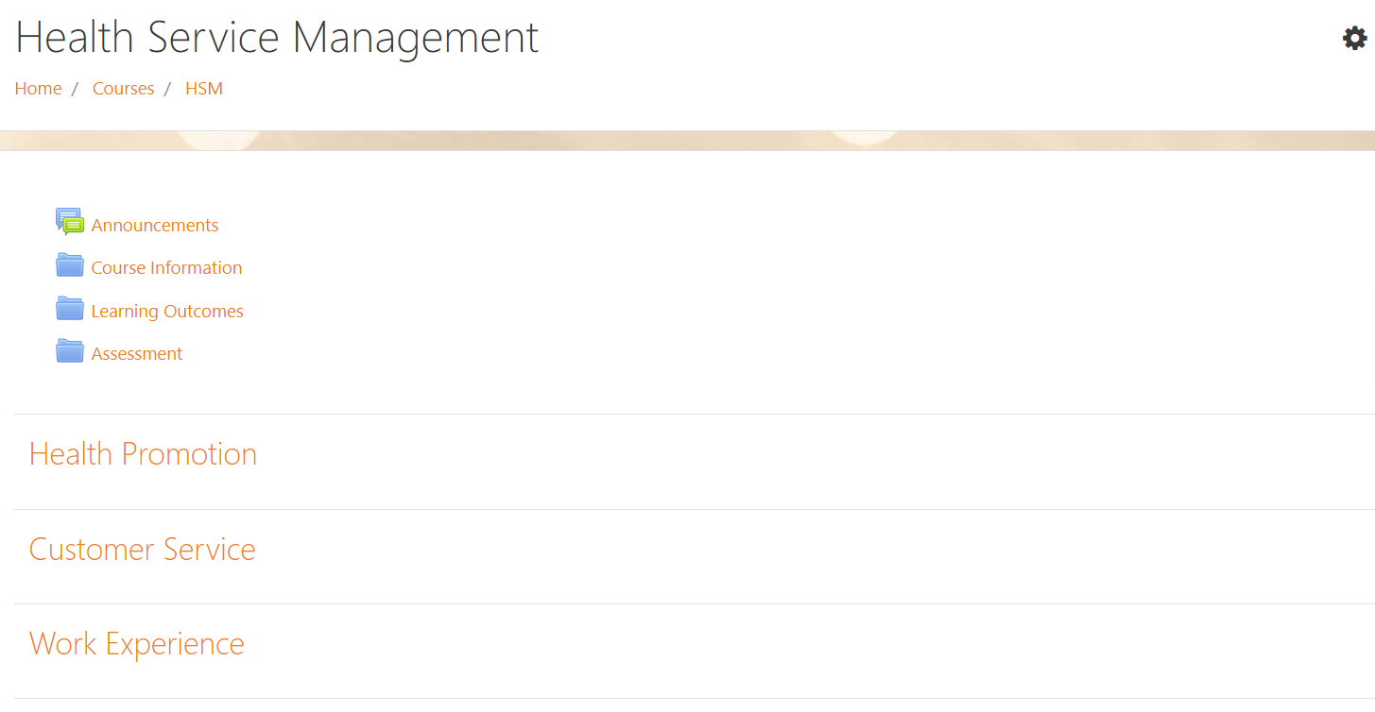
Figure 4: Sample course homepage from Moodle

The layout and design of the content for upload to the eLearning platform
The presentation of your content and how you communicate is extremely important to the learner. For each section or topic that you have created, it is necessary to deliver your content consistently. By delivering your course in a consistent format, you are helping your learners navigate the course successfully and keep track of their work. Suggestions as follows:
- font, colour, and styles should remain the same
- do not overcrowd the space with text
- state the learning outcomes at the beginning of each lesson
- the layout of content should be consistent
- set date for reading material/exercises prior to weekly webinars.

Sample module outline on Moodle

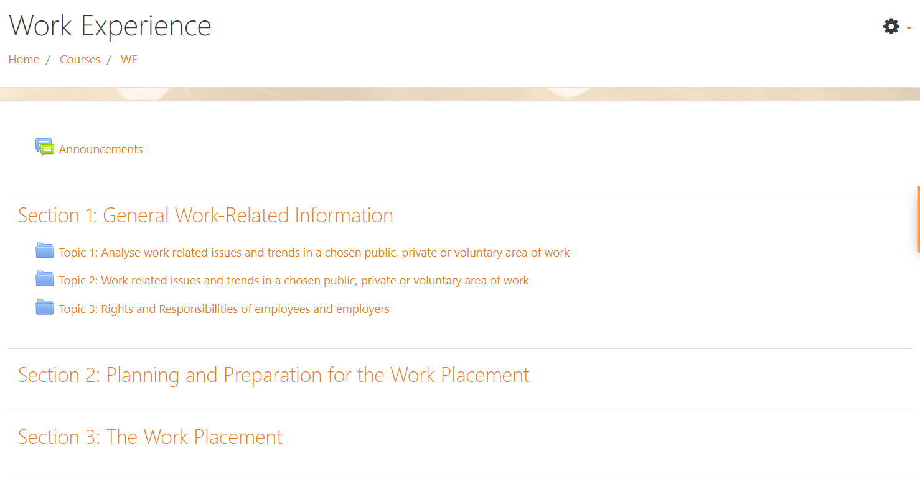
Figure 5: Sample module outline on Moodle

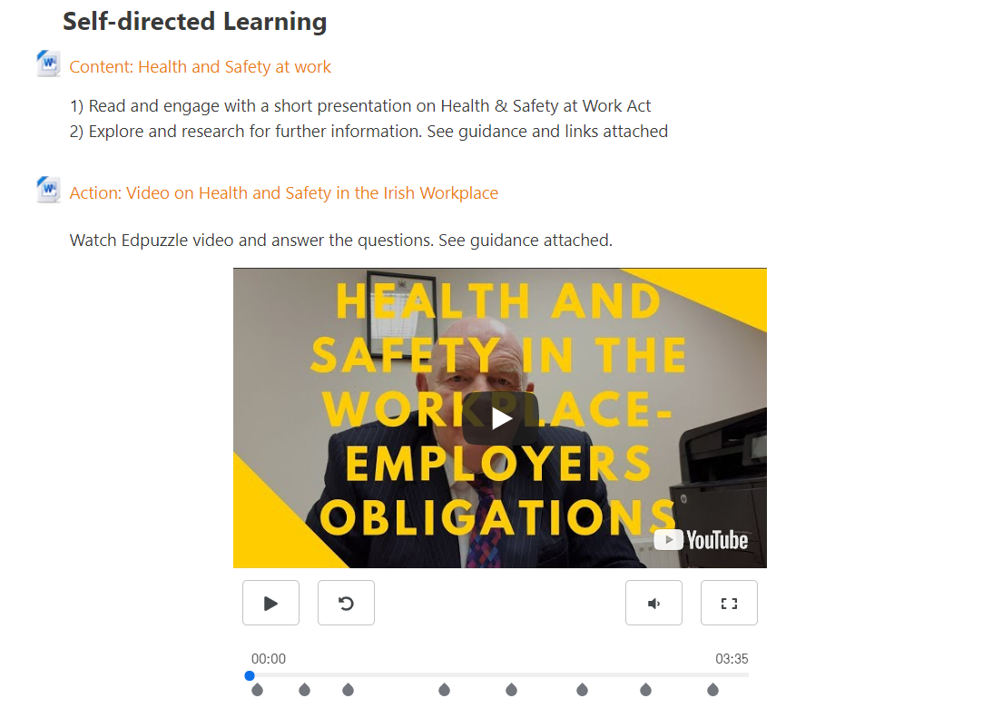

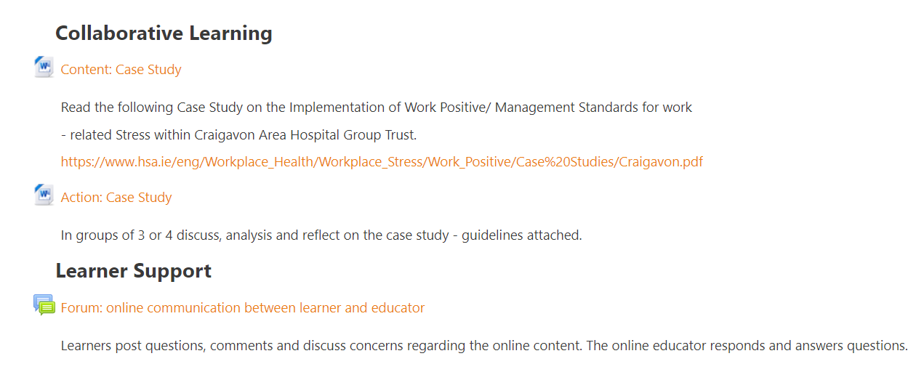
Figure 6: Sample topic outline on Moodle

Section Four: Development

As an online educator delivering a blended learning course it is necessary to keep learners engaged, create a successful learning environment, and provide a rewarding learning experience where learners feel supported and connected. This section of the handbook mainly addresses the development elements pertinent to online learning. All content developed for the blended learning course will be based on the provider’s validated programme and must be in line with the provider’s quality assurance policies and procedures for blended learning.

Creating an engaging online environment
It is important to build and maintain a vibrant online environment where learners feel they belong. Creating a strong online presence and having clear communication channels from the online educator should provide the learner with a meaningful learning experience. The following are examples of simple strategies to create an engaging learning environment for learners:

Contact learners prior to the course commencement date
- send an email message or preferably a video recording to the class to introduce yourself. The use of a video recording may provide for a more meaningful connection with some learners. Add a personal touch by including hobbies/interests so learners can get a sense of your personality and who you are. It will also introduce the learner to the concept of the use of video recordings as part of the eLearning experience
- as an alternative to sending an email or video, you could arrange a phone call or a live Zoom chat to commence building a strong rapport with learners
- provide clear instructions on how to get started in the online space with details of how to log on to the eLearning platform with learner email and password etc.

Tip: Making contact prior to course commencement is key to putting the learners at ease and creating opportunities for interaction and engagement.

Create an introductory activity/ice breaker to begin engagement on the course.
Icebreaker activities are a good way to connect your learners with each other and make them feel like they are part of a group. You may already know your learners or this may be the first time you meet your learners. It is also likely that this is the first time that the learners meet each other. Therefore, it is important to create a positive group dynamic from the beginning. For example:
- you could create a simple discussion forum for introductions. This could be a fun icebreaker, for example, where learners select their favourite place/location in the world and think of three clues that describe it. Each learner gives their name and their three clues, and the rest of the group must guess where in the world they are describing. After everyone has guessed, the person reveals their place and tells why it is their favourite place. This could take place through a discussion board on the eLearning platform or by using a digital tool like Padlet
- request learners to upload a picture to their profile and write two lines about themselves
- create a short friendly Kahoot Quiz with general knowledge or simple course-related fun questions
- allocate learners in breakout rooms for five minutes to introduce themselves to their peers allowing them to build connections.

Creating online content
There is no one way to create online content for your module. There are many different eLearning platforms, digital tools and resources out there to facilitate the creation of course content that will engage learners in the online environment. Good practice in blended learning does not necessarily mean adopting a wide range of technologies for a course. It can mean simply using a few tools, but in effective ways, to achieve quality in teaching and learning.

Tip: Educators need to consider their knowledge and skillset to create the material and their learner’s ability to interact with it – no one size fits all

Creating content is ongoing throughout the period of delivery but it is important to plan what will be developed from the beginning and use a variety of approaches and activities to keep it interesting. It is useful to consider content creation under the following headings:

creating content using digital tools to support independent learning

creating content using digital tools to facilitate collaborative learning

creating content for the virtual classroom.

Tip: It is useful to clarify for learners which resources are mandatory and which are optional/supplementary. This will clarify what the learner must read/view to complete their goal and what additional resources they can access if they so wish.

Questions you may consider when creating content to support independent learning, to facilitate collaborative learning and for the virtual classroom:

- how much content will you provide?
- what format will the content take? For example, PowerPoint with voice over, synchronous/live workshop, etc.
- what resources, in appropriate format, will you make available to learners to support their independent learning? For example, readings with interactive quiz, audio, interactive videos, posting questions, images, web links, etc.
- what guidance/instructions will learners need to effectively interact with content in the ways you require?
- how will the guidance/instructions be provided?

Tip: Keep in proportion the time, effort and resources invested in developing online content.

For example, do not spend weeks designing and developing a video for a small element of your course. As educators, you will need to think about what type of content would work best to help learners understand or to master the content.

- Creating content using digital tools to support independent learning

It is worth considering the following when developing content for upload:

most appropriate medium

length/duration of the content

keep content interesting

file size and images – be mindful of copyright

any accompanying documentation/resources

issues learners may encounter relating to devices available and internet access

how the content may appear on different devices

Tip: There are several approaches you can take to deal with file size issues, such as, compressing images or converting documents to a PDF format.

While there are many tools available online, it is important to use them appropriately and not to overuse them or to have so many in use that it becomes distracting. Below are some tips in relation to creating content when using some commonly used eLearning tools.

Presentation tools
A formal presentation of the content you wish to cover is not just useful for face-to-face class based learning but can also useful for online learning. The key things to remember are that the presentation needs to be prepared in advance, where the content is mapped out and organised in a logical sequence so that it will lead the learners through the topic from start to finish. Here are some considerations:
- keep the design of the slides simple and consistent throughout, as a variety of different designs within the same presentation can distract from the content being delivered
- text on the slides should be large enough to facilitate ease of reading
- text provided on slides should be concise and clear, keeping the number of words to a minimum
- when using images, ensure that only copyright-compliant, good quality and relevant images are used
- when using voiceover, it is useful to script the dialogue in advance and ensure that the voice is clear, audible and paced appropriately
- try to keep to no more than 30 seconds per slide
- where possible, it may be useful to include animations on slides for emphasis and to keep the learner’s attention
- take an interactive approach by including interactive points through the presentation for example, by asking questions (multiple choice/True or False/short answers) or using hyperlinks to integrate video and/or audio
- ideally there should be some sort of interaction after every 3-4 slides in order to maintain learner engagement.
Sample tools include: Google Slides, Mentimeter, Nearpod, Powerpoint and Prezi.

Videos
You can access videos from other reliable sources, or you can create videos yourself. Here are some considerations:
- if creating videos, they should be storyboarded and scripted
- ensure videos selected are relevant to the overall content
- keep videos short and not more than six minutes in length as this will assist in engaging learners.
- if possible, save videos in a compressed or lower resolution format to facilitate ease of upload for the online educator and download for the learners
- some video tools may have features that can allow you to edit and add notes and/or questions
- it is possible to create videos on your phone keeping it simple.
Sample tools include: Edpuzzle, Ted Talks and YouTube.

Screencasting
A screencast is where you are recording the activity on your screen. This can include a voiceover explaining what you are doing, which can help keep the learner’s attention. Screencasts can be used to record audio on a slide presentation or to demonstrate some skills or activities. Here are some considerations:
- ideally the length should be no longer than three minutes
- if using voice-over, it should be scripted or the key points should be identified in advance of recording
- it is recommended that longer screencasts be divided into smaller bite-sized parts and uploaded as separate learning units or activities.
Sample tools include: Camtasia, Jing, Loom, Screencast-O-Matic and Screenflow.

Quizzes
Quizzes are a useful way to engage learners. Here are some considerations:
- it is important to keep quizzes short and simple with clear guidelines and navigation so the learner always knows what to do
- consider a mix of questions for example, multiple choice, fill-in-the-blank, multiple choice, drag-and-drop and open response
- you will need to set up and test a quiz in advance so that you know that it will work when you want to use it with the learners in the online delivery of the course
- ideally learners should be told at the beginning that there will be a quiz or a number of quizzes as this may help improve their focus
- quizzes can reinforce learning by including feedback on answers given by the learner. This feedback may reinforce the learning by clearly and concisely explaining why the answer given is right or wrong.
Sample tools include: Kahoot, Mentimeter and Quizlet.

Audio files
Audio files can be useful for learning as they may be easily and repeatedly accessed by learners at a time and place that suits the learners. Here are some considerations:
- when recording an audio file, it is important to use a high-quality microphone, either a headset microphone or a mounted directional microphone
- preparation is key, turn off phones, put a do not disturb notice on the door
- minimize background noise for example by closing windows or recording in a room that is away from any source of noise
- avoid recording in rooms that have a discernible ‘echo’
- it is important to have either scripted what you are going to record or at least have the key points that you can speak to in the recording
- be yourself and do not over articulate words
- create short podcast interviews where two or more people discuss a topic and present it in an interesting way
- audio can be used to record feedback and shared with individual learners or as a group (building on educator and learner collaboration).
Sample tools include: Audacity, Teams, Phones, Zoom and SoundCloud.

- Creating content using digital tools to facilitate collaborative learning
From the start of the course it is particularly important to provide opportunities for learner interaction and collaboration. Building this into course content creates the feeling of belonging in the class, as well as developing their ability to question one another and build a deeper understanding of the topic. Different ways in which you can introduce interaction is by using discussion forums, creating study groups, blogs, wikis and by encouraging the learner to share material and resources. With each of the following tools, learners must have guidance on their role and how to behave when working in a group. Be clear about your expectations from the beginning particularly in relation to what is expected from learners when involved in any online collaborative work.

Tip: There is a strong need here for good questions/topics that learners can collaborate around.

Discussion forum
A discussion forum is a useful way of having a remote discussion with learners and between learners. This is a commonly used tool to support collaborative group work as it may encourage learners to ask questions or contribute to topics. Here are some considerations:
- it is important to notify learners when the discussion forum goes live and what the ‘closing’ date for the forum will be
- it is possible for the online educator to join or monitor the conversation to ensure that the learners stay on topic
- facilitate learners to take control and encourage peer-based collaboration.
- it can be affirming for learners if the online educator engages with the discussion forum by contributing comments
- once the topic has been sufficiently discussed post a new idea to continue peer engagement
- there needs to be clear instruction on what is expected of the learner.
Sample tools include: Padlet and discussion forum plug-ins in the eLearning platform.

Study groups
Create small online study groups or collaboration groups where learners meet away from the classroom to discuss and plan group work, assignments or revise for assessments.
Sample tools include: Google Hangouts and Microsoft teams.

Blog
A blog is a type of website where learners can contribute text, graphics and video. They consist of regular entries/posts for example, description of an event in the centre, and are displayed in chronological order. The idea is to build on a series of posts and are commonly used as online reflective journals created by individuals or groups. You can also use blogging as a group discussion about one key topic where the online educator can post an initial question/statement and the learners must respond. Here are some considerations:
- it is useful if learners are given guidance on format, ideal length and appropriate language
- it may be useful to provide a sample entry
- if using a blog for collaborative work, peers can leave their feedback/comments on the particular topic
- group contributions to blogs may enhance peer learning and engagement
- blogs can be used by online educators to address common questions or concerns.
Sample tools include: Blogspot, Wix and WordPress.

Wiki

A wiki is simple webpage where users can collaborate to create and edit content including text, images and multimedia elements. It is a useful tool for group collaboration and can be used for a range of learner activities, such as, complete a task or solve a problem that is part of a group report/project. Also useful in producing collaborative resources (e.g., web site, glossary of terms, annotated bibliography).

A wiki can also be used for individual learner activities such as:
- reflecting on learning experiences during a workplace
- create a collection of their work to be used as evidence of their skills and achievements such as in a portfolio.

Sample tools include: Fandom and Obie

Tip: Keep it simple when introducing new tools to learners as too many at one time can overwhelm both the online educator and the learner. Allow sufficient time, use a step-by-step approach and provide supplementary support if necessary, for example, written instructions, screencast or an audio recording

- Creating content for the virtual classroom

Educators and learners may still be relatively new to live online engagement. During any live online engagement, the online educator needs to convey enthusiasm and use interactive techniques to engage learners. It is important to have a well-lit and clear background for live online sessions and the option of using virtual backgrounds is provided by most platforms.
Here are some considerations:
- limit the time for sessions – no more than one and a half hour sessions
- need to plan the timings
- know what types of learning activities learners are likely to engage in
- keep sessions focused and highly interactive
- focus on one core topic with a clear purpose for the session
- ensure manageable class group sizes
- include group discussion/chat, group exercises, break-out rooms
- incorporate feedback, questions and action planning
- use functionality available on platforms, for example, chat function, Q&A, hands up, thumbs up, wave, polls, break-out sessions, record, screen share, annotate, etc.
- it is important to establish some ground rules at the start of the session, so all learners know what is expected from them and to contribute.

Tip: The key is to create opportunities for interaction and educators should use a range of techniques to keep learners engaged.

Some guidelines when delivering a live session:
- educators generally switch on their camera for everyone to help with engagement and connection
- for large class groups it is best to mute learners at the start. Either request to self-unmute or educator to unmute when a learner wishes to speak
- virtual hand raises and emojis are excellent ways to check in with the learners
- ask learners to add their questions to the chat function
- if you decide to record the webinar, it is important to let people know the session is being recorded. Confirm your provider’s policy on recording
- use a head set with a microphone to filter out background noise
- during a webinar with large groups of learners, have break-out rooms to encourage peer engagement. Provide clear instructions to complete an activity in the break-out rooms and on completion facilitate feedback to the large group
- for large groups, use polls to give learners the chance to interact with each other and then take the feedback and use it in the session.

Tip: A recording can be shared after the event with both the learners that participated and those who could not attend the live session. This allows all learners the advantage to view the content at a time that suits them

Opening 10min
Outline | Timeline | Description | Supporting Tools
Introduction | 2min | Welcome learners | Chat interaction
Learning Outcomes | 3min | Rights and responsibilities of employers and employees under Health & Safety, GDPR, Equality Act | Polls
Agenda | 2min | Case study; Health & Safety, GDPR, Equality Act, union representation
Recap | 3min | Weekly independent and collaborative learning | Polls

Core Content 35min
Outline | Timeline | Description | Supporting Tools
Instructions/discuss self-learning content | 5min | Main points of the Case Study – Sam O Donovan (Health & Safety, GDPR, Equality Act).  Provide instructions for class exercise | Share Screen – short interactive presentation using nearpod
Exercise | 10min | Learners working in small groups | Breakout rooms
Discussion and Reflection | 10min | Class group discussion – feedback from breakout rooms including reflection
Summary/reinforce learning | 10min | Short summary followed by quiz – multiple choice | Kahoot

Close 15min
Outline | TimeLine | Description | Supporting Tools
Independent learning post virtual classroom  (take-away) | 6min | Introduce trade unions and pay regulations. | Followed up with email (next day) to learners with additional reading for further understanding of the topic
Learner questions | 5min | Q&A | Chat interaction
Learner Feedback | 4min | Request learner feedback | Poll

Figure 7: Sample plan for virtual classroom (1 hour)

Section Five: Implementation
This section of the handbook mainly addresses the implementation elements pertinent to online learning. This stage involves the delivery of content to learners. It is important to facilitate remote learners to be able to engage with interactive content and to focus on key concepts using the eLearning platform. Therefore, time spent attending face-to-face in the centre or attending the virtual classroom, can be focused more on collaborative activities that clarify information provided and can encourage problem-solving, discussion or debate.

Induction
Getting off to a good start, it is important to deliver a detailed induction equipping learners with the skills necessary to successfully participate on the course.
The following is a list of suggestions for inclusion in the induction:
- introductions / ice breaker
- working together effectively – class rules, class team
- appropriate online behaviour and etiquette
- learner responsibilities such as digital identity and consequences for inappropriate online behaviour
- computer basics
  - introduce the eLearning platform including the format of weekly announcements on the platform
  - email
  - tools (one or two to start)
- time management and study skills
- assessment overview and feedback processes
- calendar/schedule of activities (weekly, monthly, etc.)
- centre policies and procedures
- support available (academic/technical/pastoral)
- online educator availability including virtual office hours and time(s) and scope of availability.

Course Delivery
Ensure that you keep your content engaging throughout the duration of the course. Think about how you planned each lesson and ensure you have a few different ways of engaging learners with your content. For example, use an anecdote in your introduction or have a story/case study woven into your presentation. Stories can also help clarify a point. Ask learners to watch and complete an Edpuzzle or participate on a forum. Introduce an audio, as a different voice can keep interest as time goes on. A good mix of all of these may help to keep learners focused.

Maintaining an engaging learning environment
Learners on blended learning programmes need regular communication and support. Therefore, it is especially important to continue to engage with learners throughout the delivery of the course.
Effective ways to continually engage and communicate with the learner during the course:
- adhere to planned educator availability. Send reminders to learners with the times that you are available both online and face-to-face to discuss any aspect of the course. This communication can be through email, online chat/forum or a synchronous online or face-to-face meeting
- schedule one-on-one sessions with each learner, to discuss their progress, concerns and to receive feedback
- reply to emails in a timely manner (ideally within 48 hours) and make time to give learners feedback on their work
- post weekly announcements informing learners about due dates, reminders of what you are covering next week, and tips for assignments, any highlights or discussion postings
- provide positive feedback to the group about their performance or constructive feedback on areas of improvement. Videos can have huge benefit and can be more engaging for the learner and have a sense of belonging
- design a Frequently Asked Questions (FAQ) page addressing many of the common questions learners have about a course. The FAQ page can serve as a valuable tool to help learners to quickly find the information they need to promote independent learning
- monitor learner’s participation and identify those who do not appear to be engaging. It is important to initiate communication with learners by email, telephone call or meeting
- provide regular recognition of learners’ engagement in the online part of the course to motivate the learners and award their effort.

Tip: It is important to create learning environments where learners are present and have a voice

Providing feedback on assessment tasks to learners
Feedback to learners on assessment tasks will be conducted by the educator in line with the provider’s quality assurance system. It is essential to clarify for learners how their mark or grade was derived, to identify and reward specific qualities in learners’ work, to guide learners on what steps to take to improve and to motivate them to act on any future assessments.
To benefit learners, feedback needs to be constructive and meaningful and provided in advance of the next assessment. Some methods for providing feedback to learners:
- email
- eLearning platform
- audio recording
- screencast
- face-to-face meeting / call
- online meeting through e.g. Zoom

Some issues that can be encountered during online delivery

The following is a list of some issues that educators may encounter with online delivery that may impact teaching and learning:
- poor communication by the online educator or learners
- passive engagement with independent learning
- passive engagement with virtual classrooms
- lack of a sense of belonging to a class group
- low levels of collaboration and social interaction
- difficulties with technology and IT support
- confusion caused for learners by introducing too many digital tools at any one time

Tip: Ensuring that the educator is present and sharing their personality with learners is key. Technology itself will not create interaction or lively learning sessions. This is the responsibility of the educator.

Section Six: Evaluation
Both as a QA requirement and a measure of good practice, feedback should be sought from relevant stakeholders on any course. This will facilitate the gathering of information on the challenges and successes associated with implementing the course and as blended learning may be new to many, it may be especially relevant in relation to a blended learning course. Generally, this feedback informs any review of the course, to make future iterations of it more effective and successful for all involved. Reviewing a course will facilitate you to reflect on your role as an online educator. It may also provide a sense of learner engagement on the course and may provide clarity about how learners felt about your interaction with them and their interaction with each other. The provider’s QA system may inform how any evaluation takes place.

A proposed model of evaluation for online learning and teaching is based around pedagogies, resources and delivery strategies (Herrington et al., 2001).
- Pedagogies are the learning activities which underpin the course
- Resources are the content and information which are provided for the learners
- Delivery strategies address issues associated with the ways in which the course is delivered to the learners
(Adapted from Herrington et al., 2001)
A combination of quantitative and qualitative research methods can be used to evaluate and reflect on the online learning environment and blended learning approach. Evaluations can be conducted, as appropriate, at different points throughout the course and with different stakeholders using suitable methodologies including questionnaires, interviews, focus groups and meetings.
The centre manager or management team should have ongoing meetings with blended learning educators to discuss issues including:
- overall blended learning approach
- course content and delivery methodologies
- educator and learner support
- IT facilities and supports.
Educators can reflect and self-evaluate through questionnaires and focus groups on their experience of the planning, designing and implementing of the blended course. It is important to get learner input to any evaluation process. Their input may be gathered by the use of questionnaires, focus groups and exit interviews (see Table 3 for sample ways to capture learner feedback).
Activities | Objectives
Learner feedback questionnaire on digital technologies | To capture learners’ learning experience in this blended course using digital tools.
Online learner feedback questionnaire (Mid and end of blended learning experience) | To capture learners’ perception and overall learning experience of the blended learning in this blended programme.
Face-to-face learner focus group (Mid-course) | To collect learners’ in-depth opinions about their blended learning experience, how learning differs from face-to-face teaching and the impact it has on their learning.
Face-to-face learner interview  (End of Course) | To gain in-depth knowledge about the learner experience in the design, effectiveness of the blended course and using digital technology, as well as the support they need.
Table 3: Examples of how learner feedback could be gathered

Ten sample questions for learner feedback on the online experience

Which aspect of the online elements of the blended course did you find most engaging?

Which aspect of the online elements of the blended course did you find most challenging?

Did you have any issues accessing information on the eLearning platform? If yes, which ones?

Did all of the web links work? If not, which ones?

Were the layout/fonts easy to read?

Did the videos and quizzes enhance the lessons?

Was it easy to contact the online tutor?

Did you receive enough support from the online educator?

Did you have any difficulty downloading any material?

Please provide one suggestion as to how this course could be improved.

Using the eLearning platform functionality to support the evaluation process

The data collected from an eLearning platform can provide an overall picture of online activities and can identify the trends of learner usage patterns, such as:

a record of learner access/login to eLearning platform

the rate of viewing/downloading the material

tracking of links accessed or not

usage of a particular activity or resource

identification of learners who may not be engaging with the course.

Reference List
Baloh, T., Neuholt Hlaster, B., Bilozerova, O., Blasi, A., Vilafranca Molero, J., Coppola, G., Agresta, F., Tozzi, A., Doyle, P., Gordon, D., Ennis, C., Manifold, P., Geiselmann, C., Feuillet, M., Schwiegar, T. and Stamouli, A., (2019) Blended Learning: Helpful tips for starting into a combination of classroom and online teaching. EU Erasmus+ Project: Hosang Communications, Germany.

Darling-Hammond, L., Wei, R., Andree, A. and Orphanos, S. (2009) Professional Learning in the Learning Profession: A Status Report on Teacher Development in the United States and Abroad. National Staff Development Council Technical Report. Available from http://outlier.uchicago.edu/computerscience/OS4CS/landscapestudy/resources/Darling-Hammond,%20Wei,%20Adnree,%20Richardson%20and%20Orphanos,%202009%20%20(1).pdf [accessed 20 July 2020].

Driscoll, M. (2015) Blended Learning: Let’s Get Beyond the Hype. IBM Global Services. Available from https://www-07.ibm.com/services/pdf/blended_learning.pdf [accessed 2 July 2020].
Services. IBM.

Driscoll, M. and Carliner, S., (2005) Advanced Web-Based Training Strategies: Unlocking Instructionally Sound Online Learning. New York: Pfeiffer.

Garrison, D. and Kanuka, H. (2004). Blended Learning: Uncovering Its Transformative Potential in Higher Education. The Internet and Higher Education Journal, 7(2), 95-105, p. 96.

Murphy, R., Snow, E., Mislevy, J., Gallagher, L., Krumm, A., and Wei, X. (2014). Blended learning Report. SRI International. Available from https://www.edweek.org/media/msdf-blended-learning-report-may-2014.pdf [accessed 3 July 2020].

Quality and Qualifications Ireland (2018). Statutory Quality Assurance Guidelines for Blended Learning. Available from https://www.qqi.ie/Publications/Publications/Statutory%20QA%20Guidelines%20for%20Blended%20Learning%20Programmes.pdf [accessed 14 July 2020].

Bibliography
Baloh, T., Neuholt Hlaster, B., Bilozerova, O., Blasi, A., Vilafranca Molero, J., Coppola, G., Agresta, F., Tozzi, A., Doyle, P., Gordon, D., Ennis, C., Manifold, P., Geiselmann, C., Feuillet, M., Schwiegar, T. and Stamouli, A., (2019) Blended Learning: Helpful tips for starting into a combination of classroom and online teaching. EU Erasmus+ Project: Hosang Communications, Germany.

Cleveland-innes, M. and Garrison, D. (2010) An Introduction to Distance Education: Understanding Teaching and Learning in a New Era. New York: Routledge.

Darling-Hammond, L., Wei, R., Andree, A. and Orphanos, S. (2009) Professional Learning in the Learning Profession: A Status Report on Teacher Development in the United States and Abroad. National Staff Development Council Technical Report. Available from http://outlier.uchicago.edu/computerscience/OS4CS/landscapestudy/resources/Darling-Hammond,%20Wei,%20Adnree,%20Richardson%20and%20Orphanos,%202009%20%20(1).pdf [accessed 20 July 2020].

Driscoll, M. (2015) Blended Learning: Let’s Get Beyond the Hype. IBM Global Services. Available from https://www-07.ibm.com/services/pdf/blended_learning.pdf [accessed 2 July 2020].

Driscoll, M. and Carliner, S., (2005) Advanced Web-Based Training Strategies: Unlocking Instructionally Sound Online Learning. New York: Pfeiffer.

Garrison, D. and Kanuka, H. (2004). Blended Learning: Uncovering Its Transformative Potential in Higher Education. The Internet and Higher Education Journal, 7(2), 95-105, p. 96.

Murphy, R., Snow, E., Mislevy, J., Gallagher, L., Krumm, A., and Wei, X. (2014). Blended learning Report. SRI International. Available from https://www.edweek.org/media/msdf-blended-learning-report-may-2014.pdf [accessed 3 July 2020].

Philadelphia Education Research Consortium (2014) BLENDED LEARNING: Defining Models of Blended Learning Programmes. Available from http://www.researchforaction.org/wp-content/uploads/2015/11/Blended-Learning-PERC-Research-Brief-September-2014.pdf [accessed 30 June 2020].

Quality and Qualifications Ireland (2018). Statutory Quality Assurance Guidelines for Blended Learning. Available from https://www.qqi.ie/Publications/Publications/Statutory%20QA%20Guidelines%20for%20Blended%20Learning%20Programmes.pdf [accessed 14 July 2020].
The Learning Rooms. (n.d.) Developing Digital Learning using ADDIE. Available from https://thelearningrooms.com/developing-digital-learning-using-addie/ [accessed 10 August 2020].

